

FACULTY OF ELECTRONICS

COMPUTER ENGINEERING AND TELECOMMUNICATIONS DEPARTMENT

LABORATORY WORK #8

Modeling 4G Mobile Coverage Optimisation

Student: Mark Mikula

Teacher: Artūras Medeišis

Vilnius, 2025

Contents

Objective and Tools 2

Section 1: Base Station Site Creation 2

Section 2: Coverage Analysis and Gap Identification 6

Section 3: Coverage Optimization Results 6

## Objective and Tools

**Objective:** This lab involves modeling 4G mobile coverage using ArcGIS. It provides insight into cell tower installation planning and strengthens understanding of GIS modeling approaches for cellular mobile network deployment.

**Tools Used:** ArcGIS with Cellular Expert integration

**Lab Environment:** The lab utilizes a previous project (Lab 7) workspace as the foundation for mobile coverage analysis.

## Section 1: Base Station Site Creation

**Objective: Model 4G mobile coverage using ArcGIS to understand cell tower installation planning.**

**Steps:**

* **Create BS site object on building rooftop location**
* **Add three cells with 120-degree azimuth spacing for complete coverage**
* **Adjust antenna height 2-3 meters above rooftop level**
* **Verify proper site-cell hierarchy in Object Editor**

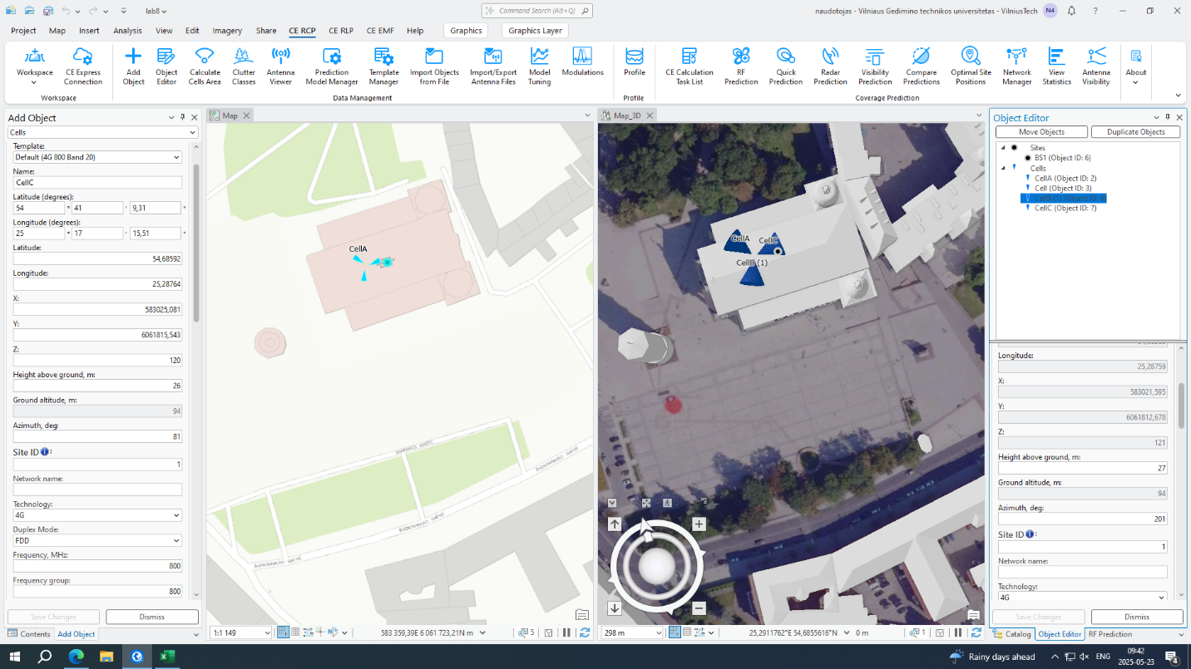

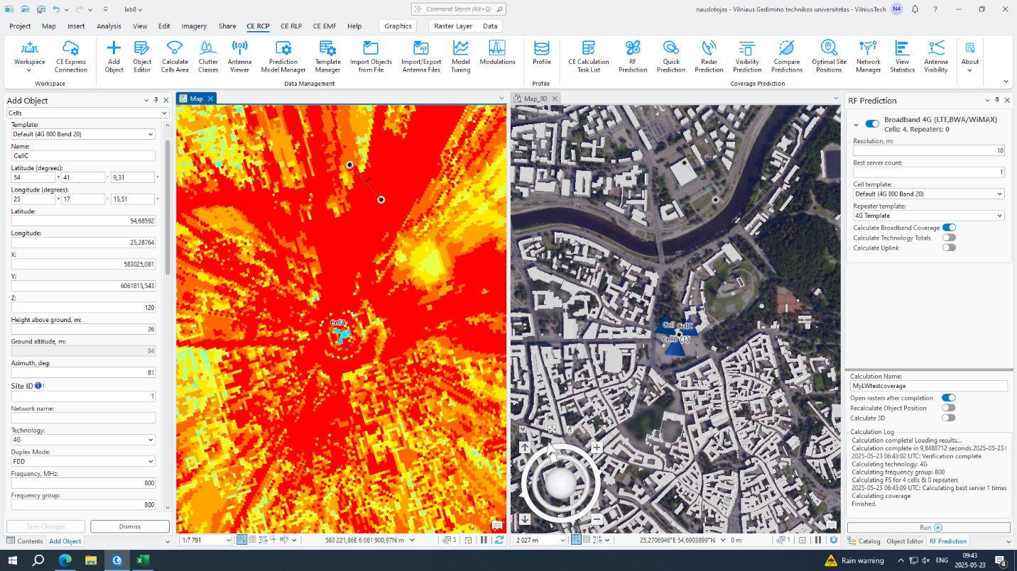 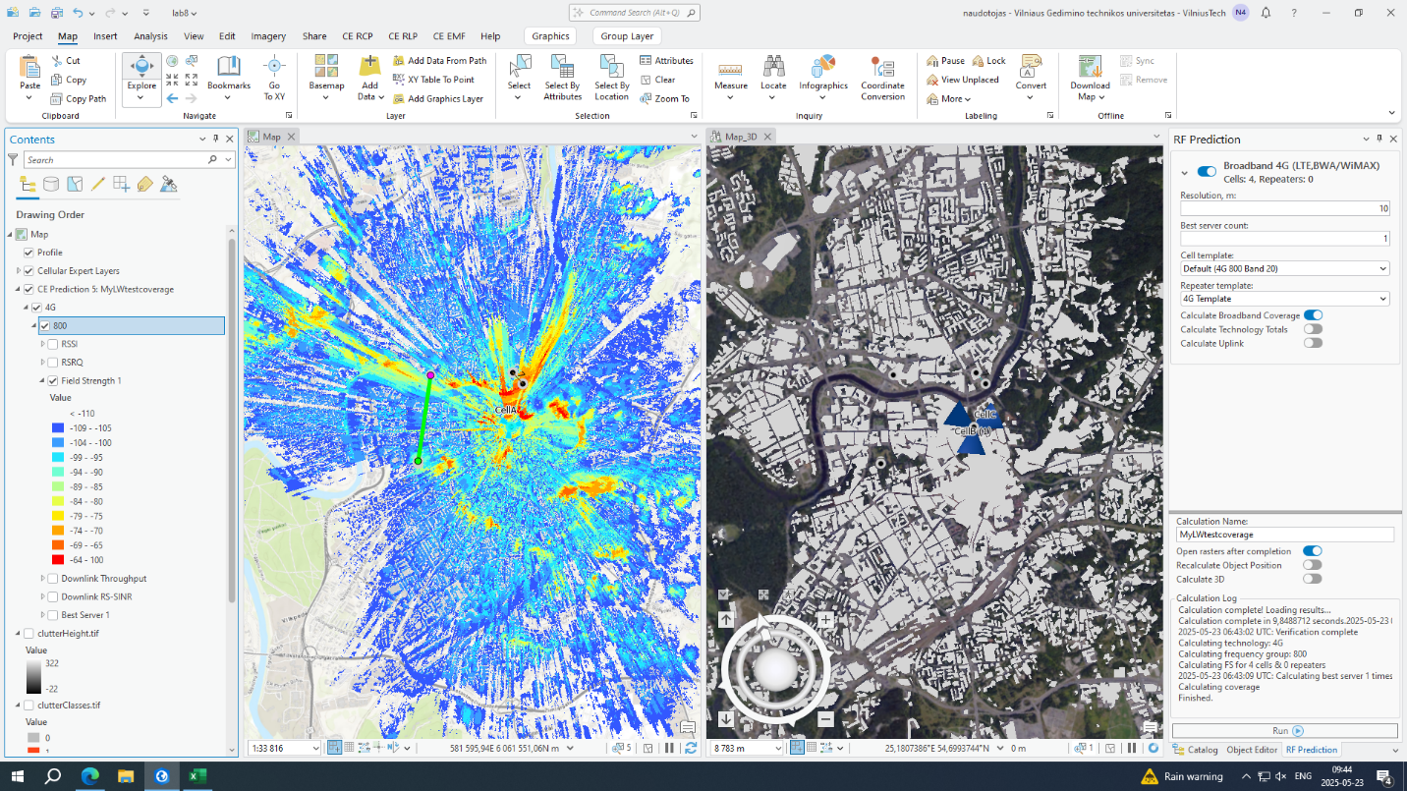 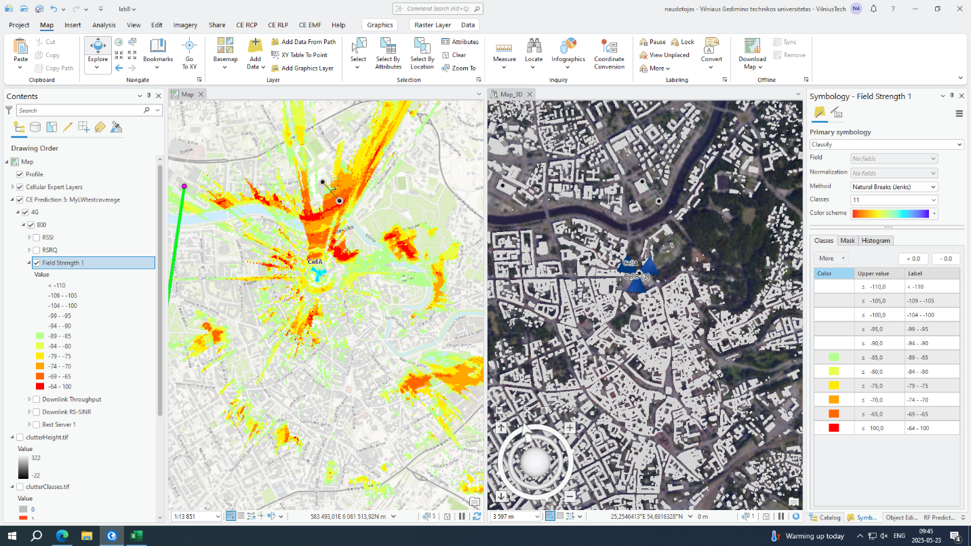 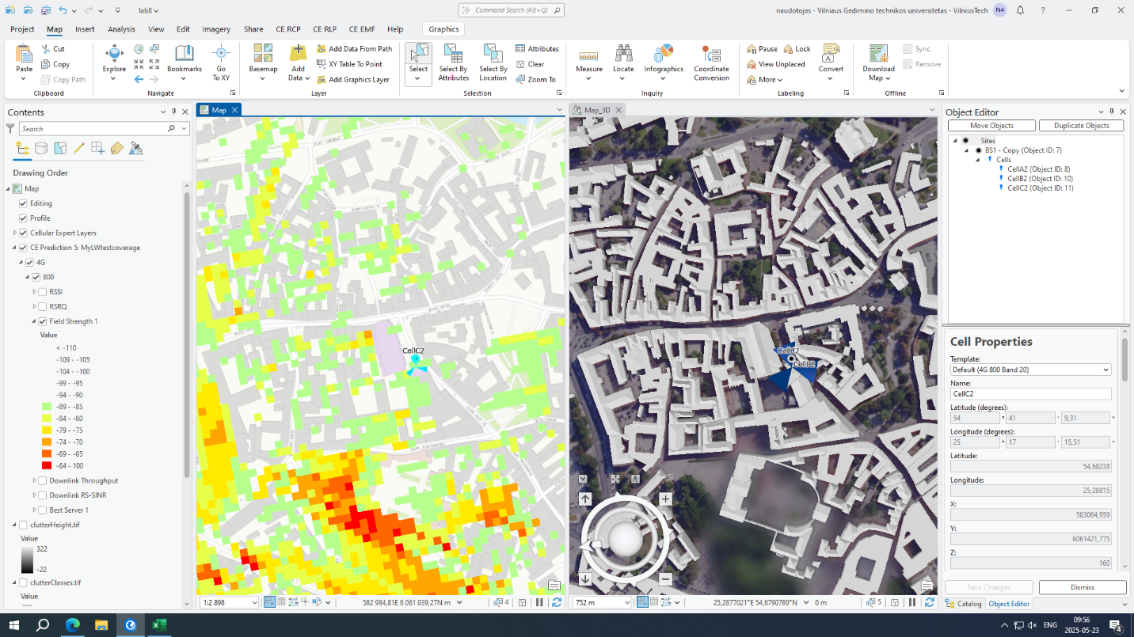

## Section 2: Coverage Analysis and Gap Identification

**Steps:**

* **Run RF Prediction simulation for single base station**
* **Filter results to show reliable coverage (-85 dBm threshold)**
* **Identify significant coverage gaps requiring additional infrastructure**
* **Create second base station in center of identified gap area**
* **Configure duplicate cells (CellBS2-A, B, C) at strategic location**

## Section 3: Coverage Optimization Results

**Comparison Analysis:**

* **Single BS: Limited coverage with significant gap areas**
* **Dual BS: Enhanced coverage with minimized dead zones**
* **Improvement: Expanded service area and consistent signal quality**

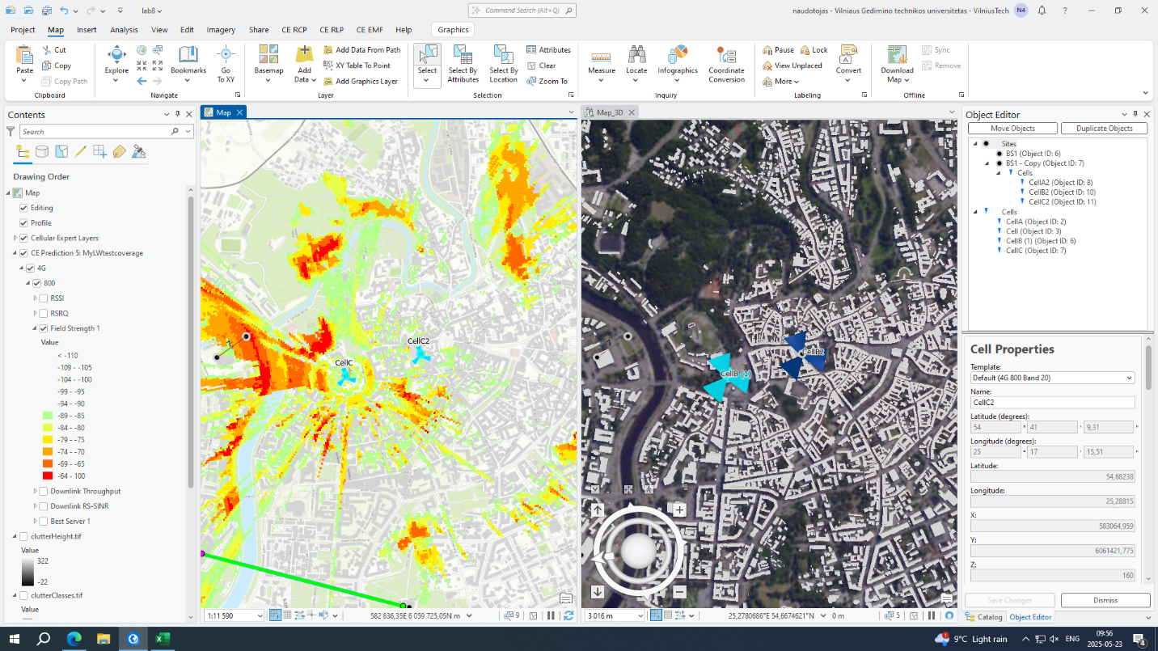 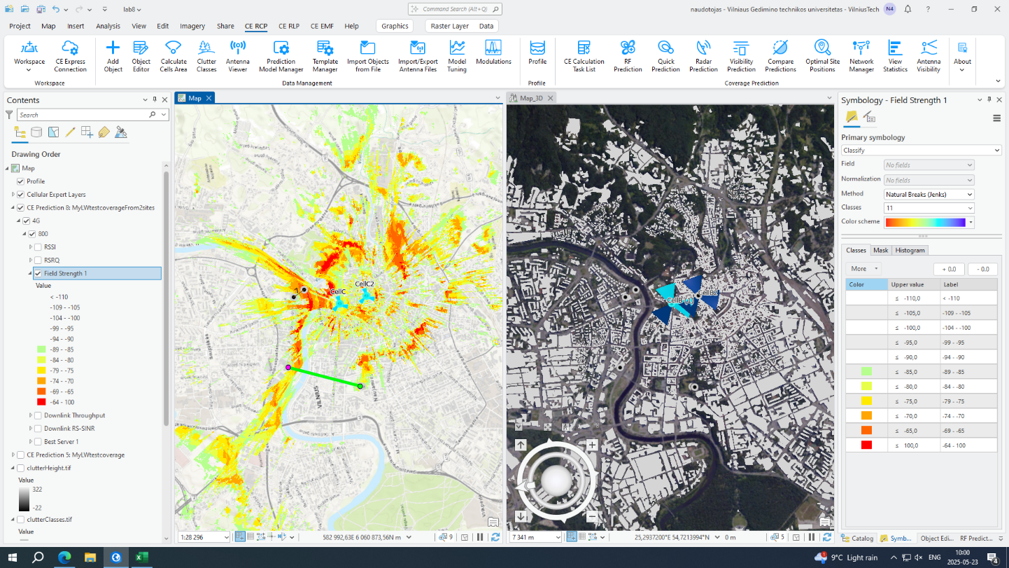Conclusion**:** Strategic placement of multiple base stations effectively addresses coverage deficiencies. GIS-based modeling enables optimal network planning by identifying gaps and validating infrastructure solutions before deployment